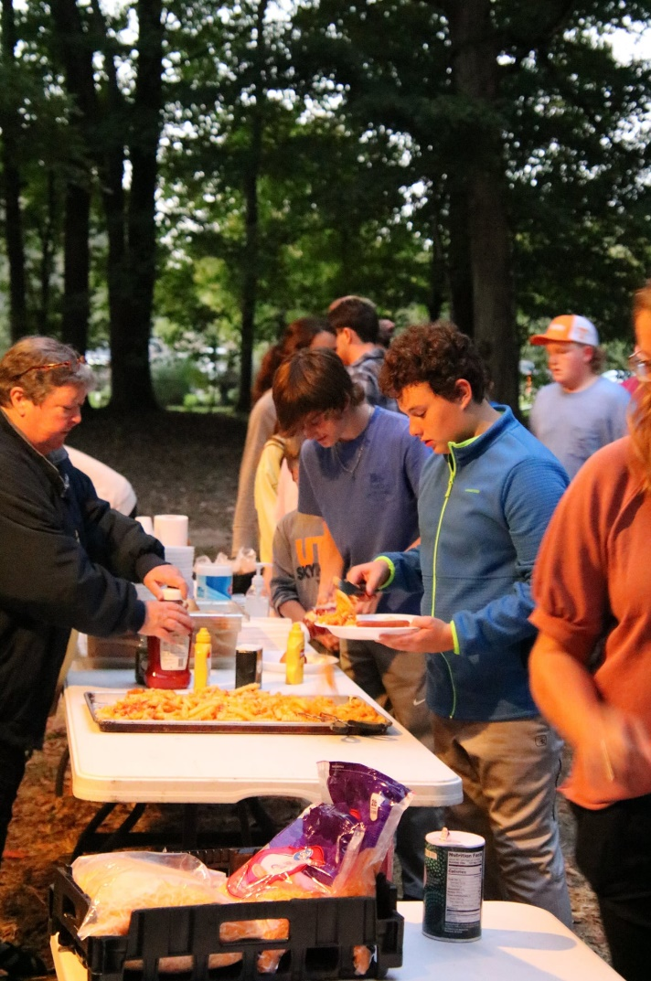

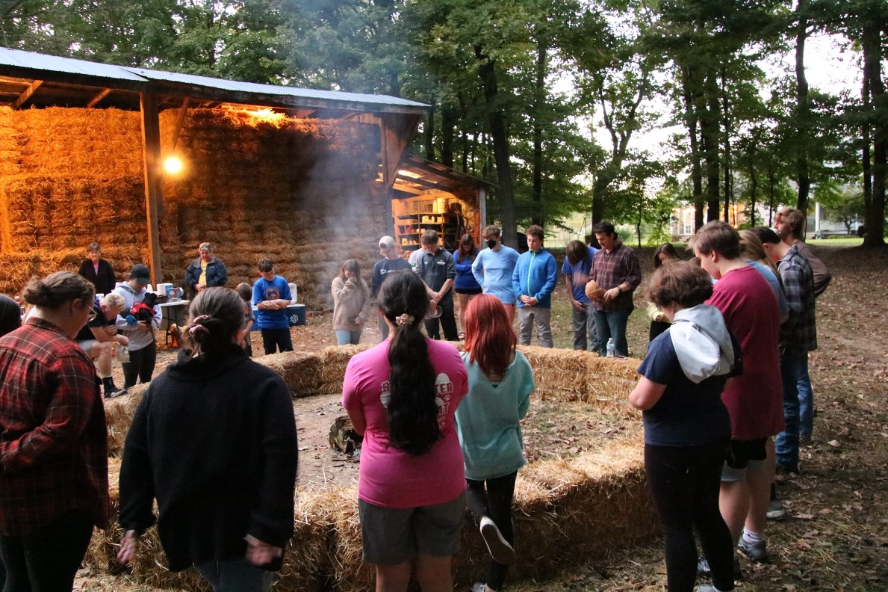

Youth Fall Fest 2021
at the Pritchett’s

Last Sunday, 30 youth along with 13 youth leaders played, ate, prayed, laughed, and fellowshipped. This fall tradition was sorely missed last fall due to Covid.

Martin First United Methodist
Worship, Nurture & Serve in Love
Twenty-Fifth Sunday after Pentecost October 24, 2021

ENTRANCE

WELCOME & ANNOUNCEMENTS

CALL TO WORSHIP Amanda Crice

PRELUDE

OPENING HYMN Joyful, Joyful, We Adore Thee 89

OPENING PRAYER

ANTHEM Ancient Words Choir

CHILDREN’S TIME

PRAYER FOR ILLUMINATION Bob Peckham (early)/Andrew Lewter (late)

OLD TESTAMENT READING Job 42:1-6, 10-17
Job answered the Lord:
I know you can do anything;
no plan of yours can be opposed successfully.
You said, “Who is this darkening counsel without knowledge?”
I have indeed spoken about things I didn’t understand,
wonders beyond my comprehension.
You said, “Listen and I will speak;
I will question you and you will inform me.”
My ears had heard about you,
but now my eyes have seen you.
Therefore, I relent and find comfort
on dust and ashes…… Then the Lord changed Job’s fortune when he prayed for his friends, and the Lord doubled all Job’s earlier possessions.
All his brothers, sisters, and acquaintances came to him and ate food with him in his house. They comforted and consoled him concerning all the disaster the Lord had brought on him, and each one gave him a qesitah and a gold ring. Then the Lord blessed Job’s latter days more than his former ones. He had fourteen thousand sheep, six thousand camels, one thousand yoke of oxen, and thousand female donkeys. He also had seven sons and three daughters. He named one Jemimah, a second Keziah, and the third Keren-happuch. No women in all the land were as beautiful as Job’s daughters; and their father gave an inheritance to them along with their brothers. After this, Job lived 140 years and saw four generations of his children. Then Job died, old and satisfied.

ACT OF PRAISE Pass Me Not, O Gentle Savior 351

GOSPEL READING Mark 10:46-52
Jesus and his followers came into Jericho. As Jesus was leaving Jericho, together with his disciples and a sizable crowd, a blind beggar named Bartimaeus, Timaeus’ son, was sitting beside the road. When he heard that Jesus of Nazareth was there, he began to shout, “Jesus, Son of David, show me mercy!” Many scolded him, telling him to be quiet, but he shouted even louder, “Son of David, show me mercy!”
Jesus stopped and said, “Call him forward.”
They called the blind man, “Be encouraged! Get up! He’s calling you.”
Throwing his coat to the side, he jumped up and came to Jesus.
Jesus asked him, “What do you want me to do for you?”
The blind man said, “Teacher, I want to see.”
Jesus said, “Go, your faith has healed you.” At once he was able to see, and he began to follow Jesus on the way.

SERMON Amanda Crice

APOSTLES CREED Bob/Andrew
PRAYERS AND INTERCESSIONS

THE GREAT THANKSGIVING

The Lord be with you. And also with you.
Lift up your hearts. We lift them up to the Lord.
Let us give thanks to the Lord our God.
It is right to give our thanks and praise.
It is right, and a good and joyful thing, always and everywhere to give thanks to you, Father Almighty, ….. And so with your people on earth and all the company of heaven we praise your name and join their unending hymn:
Holy, holy, holy Lord. God of power and might, heaven and earth are full of your glory. Hosanna in the highest. Hosanna in the highest. Hosanna in the highest. Blessed is the One who comes in the name of the Lord. Hosanna in the highest. Hosanna in the highest. Hosanna in the highest.
Holy are you and blessed is your Son Jesus Christ…. And so in remembrance…as we proclaim the mystery of faith. Christ has died; Christ is risen; Christ will come again. Hosanna in the highest. Hosanna in the highest. Hosanna in the highest.
Pour out your Holy Spirit on us gathered here,…. All honor and glory is yours, Almighty Father, now and forever.
Amen. Amen. Amen. Hosanna in the highest. Hosanna in the highest. Hosanna in the highest.
SENDING FORTH
United Methodist Women’s Prayer Calendar
Mission Focus—USA
Charlotte, North Carolina—Bethlehem Center—
Providing high-quality education and support for
children in need through partnership with their families
Mission Focus—International
Panama—Panama Methodist Camping Ministry—
Providing an optimal place for the transformation
of lives through Christian camps and similar
spiritual growth opportunities

HYMN Open My Eyes, That I May See 454

BLESSING AND POSTLUDE

INTERCESSORY PRAYER CONCERNS:
Ongoing Concerns: Marilucile Counce, Dale Overton, Carolyn James, Allison Stockton. Robert Mancusi, Mary Beard, Kathy Vowell, Tom Harrington, Traci & Rachel Bowlin, Becky Brigance, Frances Brewer, Donna Flynt, Peggy King, Amanda Freeman, Steve McConnell, Angie Damron, Virginia Clendenin, Jerry Brigance, Chris Bowman, Diane Broughton, Charline Freeman, Mary Beard, Alan Moody, Billie Sue Walker, John Overcash, Bob Smith, Jill Brigance, Kathy Prewett, Gail Yates, Bishop Bill McAlilly, Superintendent Cynthia Davis, We Care Ministries. UTM Wesley
Prayers for Friends and Relatives: Linda & Wally Crider’s daughter, Kristi Jones. Michelle Kimsey. Michael Johnson’s father, Jerry Johnson. ReneeLaFleur and Ricky Garlitz upon the death of daughter, Eleanor. Austin Hicks. Caroline Ideus’ aunt. Susan Kilgas’ father, Lewis Byassee, and her Aunt Margaret Robinson on the death of her husband, John Robinson. Steve Kilgas’s sister, Carol Hounshel. Daryl Byford’s friend Nathaniel Hill. Debbie Jorge’s cousin, Kelli Barnes. Jennifer Snider’s sister, Nancy Jones, upon the death of her husband, Gary Jones; Kristy Shumake’s mother, Brenda Dublin. Jeff and Allison Stockton’s parents. Rosemary Coleman’s daughter-in-law’s mother, Joyce Ashe. David Murphy. Staci Mancusi’s grandmother, Doris Davidson. Glenda Nanney’s son-in-law, Michael Hester. Vicki Greer & Family. Angie Damron’s son and Dawne Belote’s brother, Steve Damron. Mack Thornton’s brother-in-law, Butch Henley, and sister-in-law, Linda Cushman. Erica Bell’s father, Don Griffin. Peggy King’s son-in-law, George Frels and friend, Leslie Justice. Jeff Stockton’s friend, Becky Tofte. Jenise Butler’s cousin, April. Susan Parr.

Church Family Update
As we pray, friends, Marilucile Counce is now at Weakley County Nursing Home after spending a few days in a Jackson Hospital.

IMPORTANT: Effective October 29, 2021 the current SecureGive portal will be taken down. A new online giving portal supported by icheckgateway which will allow payments direct from your bank account and/or all major credit cards (Visa, MasterCard, Discover and American Express). This new portal will go live on our website as of November 1, 2021. We are so thankful for your faithful giving and pray for a smooth transition. Should you have any questions or concerns, please do not hesitate to contact Kathy Smith either by e-mail (treasurer@martinfumc.org) or telephone (731-587-2689).

Christmas Country Store & Bake Sale opens Sunday!
The Country Store and the Bake Sale will OPEN this Sunday in the Narthex! You'll have the first opportunity to select scrumptious holiday treats! Like last year, you choose an item and fill out the card. The baker will be notified and make it just for YOU! Call the office and Judy will help you.
Some fall crafts and canned food is available today! All proceeds benefit local missions.
Calendar
Today, October 24
4:00 Worship Committee on Advent/Pastor’s study
5:00 Pumpkins & Buntings Young Adult Gathering at The Borden’s
Monday, Oct. 25
3:00 ROOTS
Wednesday, Oct. 27
9:30 Bazaar Workshop
6:00 Youth Cue
7:00 10:50 Choir Rehearsal/Choir Room

Sunday, October 31
3:00-4:00 Trunk & Treat

NOTE: Our Charge Conference will be Sunday, November 14, at 1:00 p.m. in the sanctuary. The whole church is welcome to attend.
Financial Update
October 18, 2021
2021 Budget |  | 688,630
Needed weekly |  | 13,243
Given Week ended 10/18/21 |  | 9,427
Total needed for Budget thru 10/18/21 |  | 556,206
Giving to Budget thru 10/18/21 |  | 451,313
Amount Giving less than Budget |  | (104,893)

