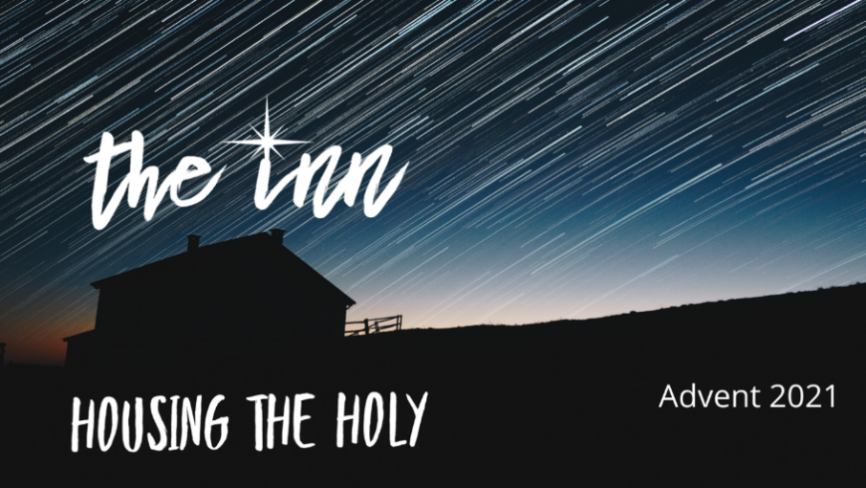
Martin First United Methodist
Worship, Nurture & Serve in Love
First Sunday of Advent - Hope November 28, 2021
ENTRANCE

WELCOME & ANNOUNCEMENTS Amanda
PRELUDE

CALL TO WORSHIP Bryant Fisher

Hope waits for us at Advent

OPENING PRAYER/ADVENT WREATH Bane Family
OPENING HYMN Hail to the Lord’s Anointed 203

CHILDREN’S TIME

PRAYER FOR ILLUMINATION Bane Family

OLD TESTAMENT READING Jeremiah 33:14-16
The time is coming, declares the Lord, when I will fulfill my gracious promise with the people of Israel and Judah. In those days and at that time, I will raise up a righteous branch from David’s line, who will do what is just and right in the land. In those days, Judah will be saved and Jerusalem will live in safety. And this is what he will be called: The Lord Is Our Righteousness.
ANTHEM Advent Hymn Choir

OLD TESTAMENT READING Psalm 25:1-10
I offer my life to you, Lord.
My God, I trust you.
Please don’t let me be put to shame!
Don’t let my enemies rejoice over me!
For that matter,
don’t let anyone who hopes in you
be put to shame;
instead, let those who are treacherous without excuse be put to shame.
Make your ways known to me, Lord;
teach me your paths.
Lead me in your truth—teach it to me—
because you are the God who saves me.
I put my hope in you all day long.
Lord, remember your compassion and faithful love—
they are forever!
But don’t remember the sins of my youth or my wrongdoing.
Remember me only according to your faithful love
for the sake of your goodness, Lord.
The Lord is good and does the right thing;
he teaches sinners which way they should go.
God guides the weak to justice,
teaching them his way.
All the Lord’s paths are loving and faithful
For those who keep his covenant and laws.

SERMON Rev. Amanda Crice

VOW OF HOLY MEMBERSHIP Jake, Bethany, Millie, & Matthew Hart

PRAYERS and INTERCESSIONS

OFFERING USHERS: Alex, Barrett & Cole Belew, Mary Anna Chester

SPECIAL MUSIC OFFERING Messiah or Stranger Bob Peckham

DOXOLOGY

THE GREAT THANKSGIVING

The Lord be with you. And also with you.
Lift up your hearts. We lift them up to the Lord.
Let us give thanks to the Lord our God.
It is right to give our thanks and praise.
It is right, and a good and joyful thing, always and everywhere to give thanks to you, Father Almighty, ….. And so with your people on earth and all the company of heaven we praise your name and join their unending hymn:
Holy, holy, holy Lord. God of power and might, heaven and earth are full of your glory. Hosanna in the highest. Hosanna in the highest. Hosanna in the highest. Blessed is the One who comes in the name of the Lord. Hosanna in the highest. Hosanna in the highest. Hosanna in the highest.
Holy are you and blessed is your Son Jesus Christ…. And so in remembrance…as we proclaim the mystery of faith. Christ has died; Christ is risen; Christ will come again. Hosanna in the highest. Hosanna in the highest. Hosanna in the highest.
Pour out your Holy Spirit on us gathered here,…. All honor and glory is yours, Almighty Father, now and forever.
Amen. Amen. Amen. Hosanna in the highest. Hosanna in the highest. Hosanna in the highest.
SENDING FORTH

HYMN O Little Town of Bethlehem 230

BLESSING AND POSTLUDE

INTERCESSORY PRAYER CONCERNS:
Ongoing Concerns: Caroline Ideus. Mary Fleck. Donnie Davis. Terry Boyd. Lynn Gibson. Lenore Christiansen. Alex Campbell and Family. Peggy King. Marilucile Counce. Carolyn James. Alliston Stockton. Robert Mancusi. Mary Beard. Kathy Vowell. Tom Harrington. Traci & Rachel Bowlin. Becky Brigance. Frances Brewer. Donna Flynt. Amanda Freeman. Steve McConnell. Angie Damron. Virginia Clendenin, Jerry Brigance. Chris Bowman. Diane Broughton. Charline Freeman. Alan Moody. Billie Sue Walker. John Overcash. Bob Smith. Jill Brigance. Kathy Prewett. Gail Yates. Bishop Bill McAlilly. Superintendent Cynthia Davis. We Care Ministries. UTM Wesley
Prayers for Friends and Relatives: Val Combs’ fiancée, Shayne. Steve McConell’s girlfriend, Faye. Family of Kelli Barnes. Linda & Wally Crider’s daughter, Kristi Jones. Amy Todd Brown. Michelle Kimsey. Renee LaFleur and Ricky Garlitz. Austin Hicks. Susan Kilgas’ father, Lewis Byassee, and her Aunt Margaret Robinson.Steve Kilgas’s sister, Carol Hounshel. Jennifer Snider’s sister, Nancy Jones. Kristy Shumake’s mother, Brenda Dublin. Jeff and Allison Stockton’s parents. Rosemary Coleman’s daughter-in-law’s mother, Joyce Ashe. David Murphy. Staci Mancusi’s grandmother, Doris Davidson.
Glenda Nanney’s son-in-law, Michael Hester. Vicki Greer & Family. Angie Damron’s son and Dawne Belote’s brother, Steve Damron. Mack Thornton’s brother-in-law, Butch Henley, and sister-in-law, Linda Cushman. Erica Bell’s father, Don Griffin. Peggy King’s son-in-law, George Frels and friend, Leslie Justice. Jeff Stockton’s friend, Becky Tofte. Jenise Butler’s Cousin, April. Susan Parr.
United Methodist Women’s Prayer Calendar
Mission Focus—USA Unalaska United Methodist Church—Outreach and Community Ministry—Ministering to the Bering Sea fishing fleet, processors, stranded crew members and the community
Mission Focus—International South Africa—John Wesley Community—Providing education, food and support for vulnerable children and orphans with AIDS

As we pray, friends
During Advent (Nov. 28-Dec. 26) there will be one worship service at 10:00 and Sunday School will begin at 9:00. We look forward to preparing for our Savior's birth together. Christmas Eve Service will be at 5:00 p.m.

Christmas Poinsettia Plants
If you’d like to help decorate the sanctuary for Christmas by donating a poinsettia plant in memory or in honor of a loved one, a plant is $15. Please contact the office. If you’d like an acknowledgement card sent, please include an address. You’ll be able to take home a plant after Christmas Eve service.
Memorials & Honorariums
Honoring and remembering those we love…
Budget in honor of Jennifer Moody’s mother, Carolyn
Budget in memory of Tine Vowel, Bob & Betty Cheeseman

Calendar

Monday, November 29
2:30 ROOTS
Tuesday, November 30
7:00 pm Beyond Just Mercy
Wednesday, December 1
6:45 am UMM/FHall
5:30pm Live at the Market
Children’s Library
All the Colors of Christmas in memory of Billy Hatchel

