Office Hours: Mon-Thurs 8-12 & 1-5

Closed Friday

Pastor, Amanda Crice
Monday 9:00 - 3:30; Tues. study out of the
office; Wednesday & Thursday 9:00-4:00
Friday or Saturday: Sabbath depending on
the ministry needs of the week.

Discipleship & Spiritual Formation Director, Karastin Hancock
Monday, Wed. & Thurs. 9:00-4:00
Tuesday work out of the office
Friday or Saturday: Sabbath depending
on the ministry needs of the week

Director of Music & Worship Arts,
Chrissy Hamilton
Monday & Wednesday 8:00-2:00
Sunday Worship 10:00

Pastor of Students & Nurture, Bryant Fisher
Monday 8:30-4:00, Tues. 9:00-4:00
Wed. & Thurs. 7:30-2:30, Friday Sabbath

Director of Children, Jennifer Vincent
Monday 8:00-5:00 (ROOTS 3:00-5:00)
Tuesday & Wednesday 8:00-11:00

Financial Secretary, Kathy Smith,
Wednesday 8:30-4:00

Administrative Assistant, Judy Mehan
Mon., Tues., Wed., Thurs 8:00-5:00

Building & Grounds Supervisor, Ken Hogan
Mon, Tues, Wed, Thurs, Friday 7:30-4:00

Chancel Choir Director, Robert Mancusi

Minister of Visitation, Bro. Randy Cooper

2024 Council Chair: Claire Wade
Lay Leader: Andy Lewter
Worship Chair: Vicki Smith
Nurture Chair: Caroline Ideus
Serve Chair: Mary Margaret Chester

Director of Children, Jennifer Vincent
Monday 8:00-5:00 (ROOTS 3:00-5:00)
Tuesday & Wednesday 8:00-11:00

Financial Secretary, Kathy Smith,
Wednesday 8:30-4:00

Administrative Assistant, Judy Mehan
Mon., Tues., Wed., Thurs 8:00-5:00

Building & Grounds Supervisor, Ken Hogan
Mon, Tues, Wed, Thurs, Friday 7:30-4:00

Chancel Choir Director, Robert Mancusi

Minister of Visitation, Bro. Randy Cooper

2024 Council Chair: Claire Wade
Lay Leader: Andy Lewter
Worship Chair: Vicki Smith
Nurture Chair: Caroline Ideus
Serve Chair: Mary Margaret Chester

INTERCESSORY PRAYER CONCERNS: We ask for your prayers and continued prayers for these we know of. Several more have asked us to keep their situations private. If God places someone’s name on your heart, please consider sending a note or giving them a call.
Ongoing Concerns: Our confirmands and their mentors. Mindy Schmidt. David Reed. Don Clements. Ryan Martin. Sandra Powell. Bobby Wright. Donna Webb. Camille Legins. Dee Cannon. Wally Crider. Devon & Amanda Jackson. Leslie Morris. Mary Beard. Mack Thorton. Glenda Nanney. Angie Damron. Linda Davis. Helmut Wenz. Magen, Braden and Jase Cooper. People in Israel and Palestine. Jean Vincent. Steve Mohler. Patsy Coates. Dale Overton. Dotsie Clifton. Bishop McAlilly. Marion Pitts. Jim & Jane Rea. Bella Mancusi. Rosemary Capers. Betty Henderson. Diane Broughton. Chris Smith. Donna Flynt. Pat Page. Paula Moore. Gail Smith. Kay Carroll. Peggy, Terry & Will King. Linda Hall. Marilucile Counce. Janice Noble. Keath Turner. Sarah Byars. Kristin Havener’s son, Kaden. Jim & Gina Johnson. Gail Beard Yates. Janiece Peeler. Frances Brewer. Chris Bowman. Alan Moody. Bob Smith. District Superintendents Stephen Handy & Nancy Varden. We Care Ministries. UTM Wesley. Dresden UMC. Prayers for Friends and Relatives: Shantelle Gilliam’s mother, JoAnn Brown. Dave Politte’s son, Carrington Politte. Bill & Claudia Porter’s daughter. Jeff Stockton’s dad, Sam Stockton. Susan Kilgas’ friend, Sandi Spragins. Phil Wade’s father, Jesse Wade. Jen Galey’s mother, Janet Flynn. Mary Beard’s friend, Jo Bargenquast. Allison Stockton’s father, Ronnie Albright. Courtney Haley’s friend’s father, Brad Byars. Dee Cannon’s friend, Ron Powers. Traci Bowlin’s cousin, Kelly. Chris Bowman’s father. Kim Turner’s mother, Wilda Simmons. Dave Politte’s brother, Alan. Kayci Borden’ father, Gary Henline. Michael Johnson’s aunt, Jennifer Johnson. Janice Noble’s sister, Peggy. Roger Johnson’s mother. Crawford & Nancy Gallimore. Amy Todd Brown. Renee LaFleur and Ricky Garlitz. Kristy Shumake’s mother, Brenda Dublin. Rosemary Coleman’s daughter-in-law’s mother, Joyce Ashe. David Murphy. Peggy King’s son-in-law, George Frels and friend, Leslie Justice.
Martin First United Methodist Church
Worship, Nurture and Serve in Love
March 24, 2024
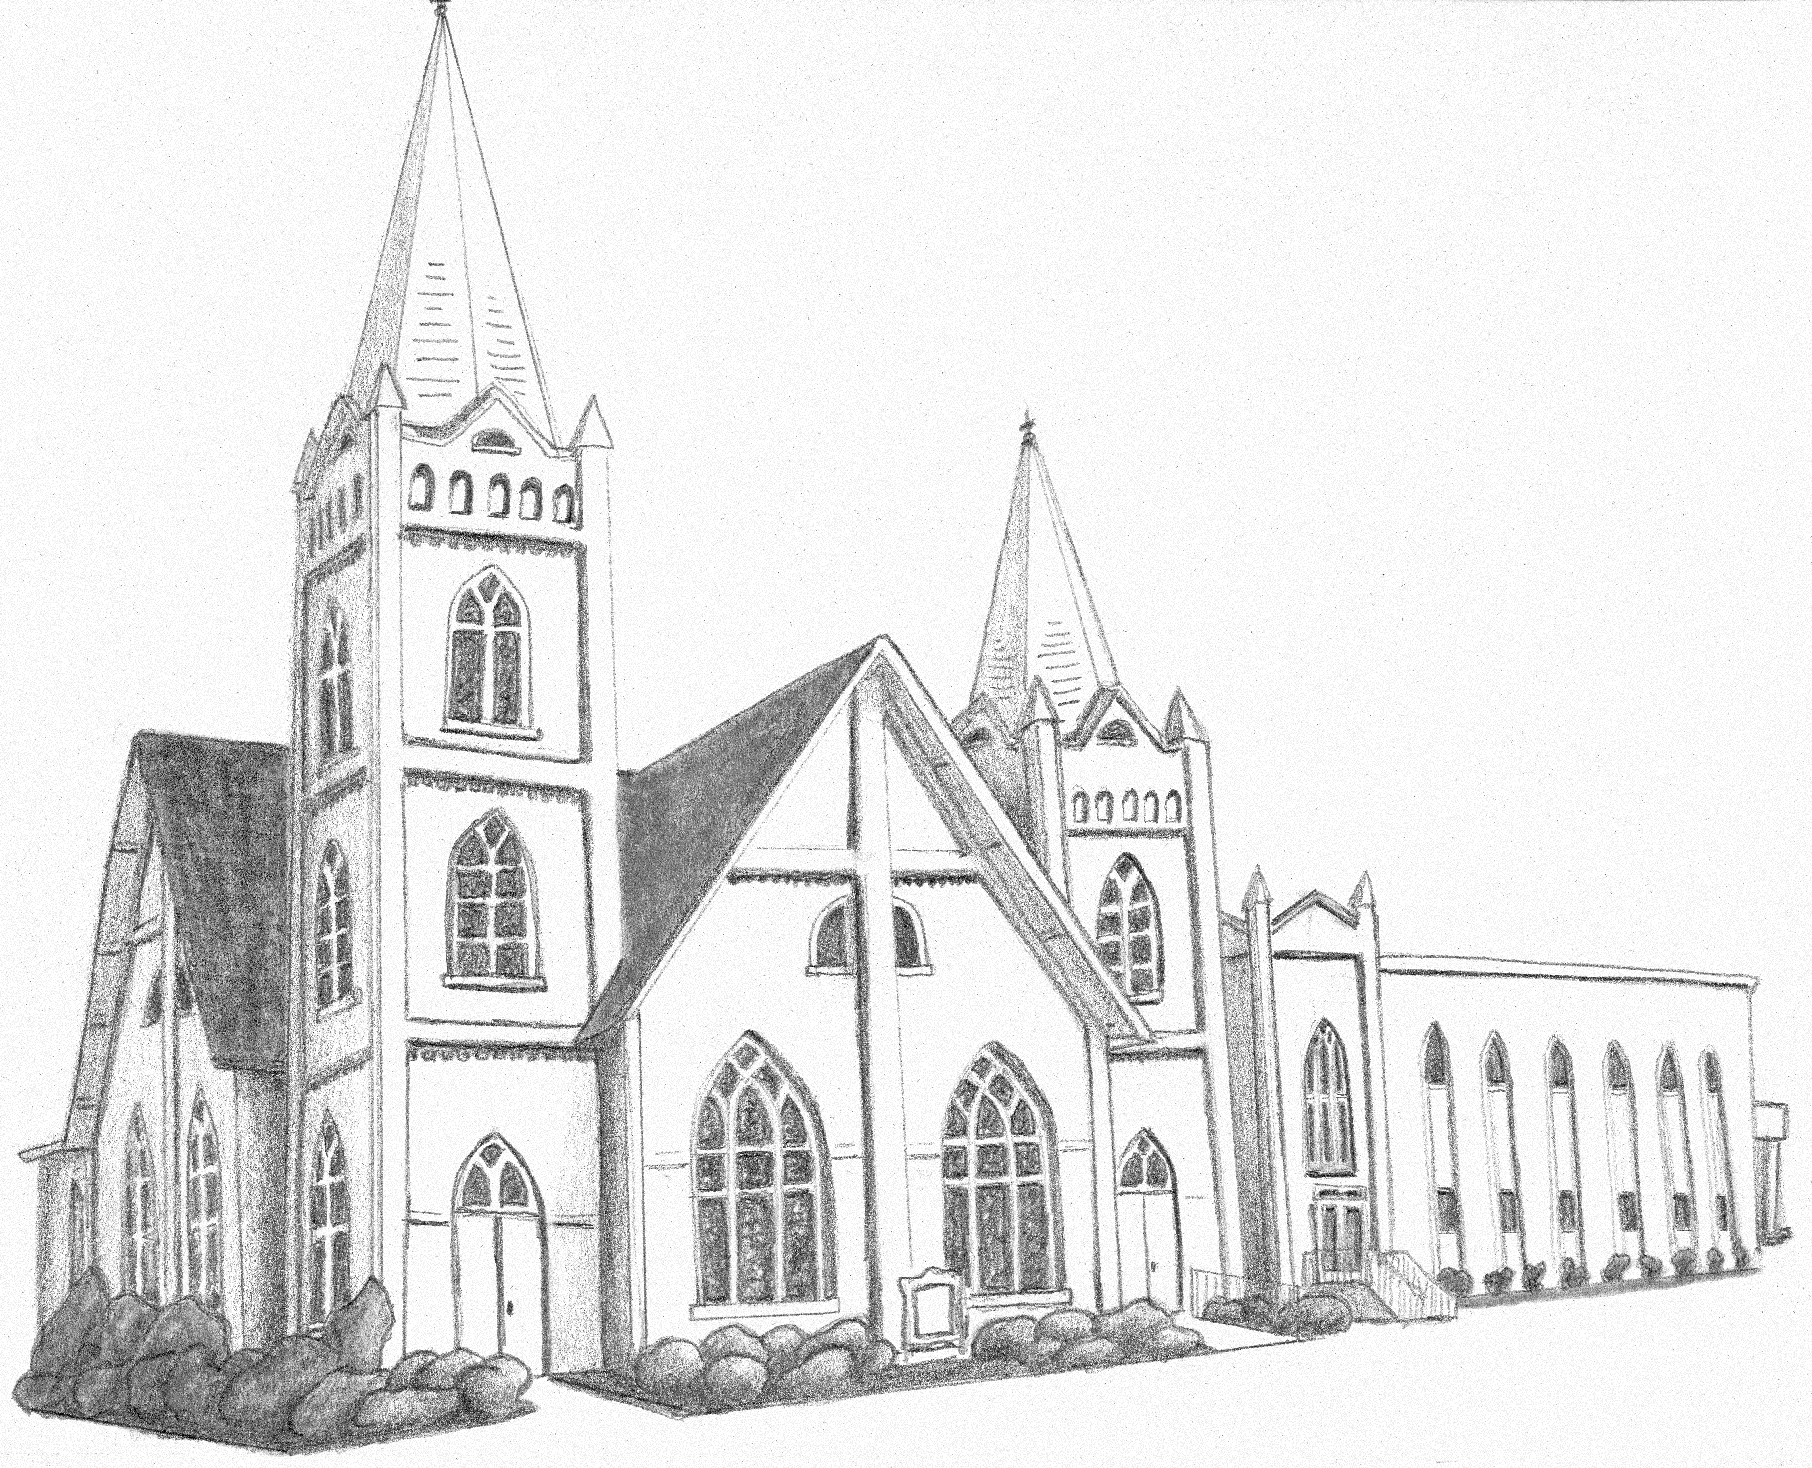
ENTRANCE
WELCOME & ANNOUNCEMENTS
Pastor Amanda Crice

PRELUDE Roger Johnson

CALL TO WORSHIP Come Thou Fount
OPENING PRAYER Pastor Amanda /
OPENING HYMN Hosanna, Loud Hosanna 278

PROCLAMATION & RESPONSE
PRAYER FOR ILLUMINATION Pastor Amanda
GOSPEL John 12:12-16
ROOTS Skit & Children’s Time
Christ-centered people who worship God, nurture disciples, and serve our neighbors with love.

John 13:1-20
ACT OF PRAISE Song of Remembrance Choir
John 13:31-38, John 18:1-11
Meditation Pastor Amanda
John 18:12-18, John 18:19-27; John 19:1-30
PRAYERS OF THE PEOPLE Pastor Amanda
OFFERING
Offering steward: Mike Hinds

DOXOLOGY

THANKSGIVING & COMMUNION

HOLY COMMUNION

SENDING FORTH

HYMN Go to Dark Gethsemane 290

BENEDICTION

ASSISTING IN WORSHIP: Caleb Shumake,
Caden Neville & Justin Crice

HAPPENINGS

Today is the last day to contribute to a love offering for Mona, guide to our Holy Land team last fall. Your donation can be placed in the collection plate.

If you’d like to help decorate the sanctuary for Easter by donating an Easter Lily plant in memory or in honor of a loved one, a plant is $20. Deadline is TUESDAY.
Calendar
Sunday, March 24
1-3 Baby Shower for Jace Cooper/parlor
3:00 Lenten Small Group/Wesley at UTM
Orchestra/Sanctuary
4:00 Hands for Him
Weakley County Schools Spring Break
Monday, March 25
12:00 Holy Week Service/Trinity Presbyterian
Tuesday, March 26
12:00 Holy Week Service/Wesley at UTM
Wednesday, March 27
9:30 Bazaar Workshop
5:30 Disciple 1 & 2
7:00 Choir/choir room
Thursday, March 28
6:30 Maundy Thursday/Trinity Presbyterian
Friday, March 29
12:00 Holy Week Service/here
Prayer Stations/sanctuary
6:30 Good Friday service/McCabe UMC
Sunday, March 31 Easter He is Risen!
6:00 Sunrise Service
10:00 Worship in sanctuary
4:00 Easter Friends Potluck/FHall

Trained Stephen Ministers are available if you need someone to talk to. Contact Pastor Amanda.

The Resurrection Team would like to invite you to continue your Lenten study, Wandering Heart, on Good Friday after our noon day service until 5:30pm. The sanctuary will be open to anyone who would like to come and sit in prayer alone or pray with one of our members. There will be 6 stations that will walk you through Peter’s “way of sorrows” and his role in the crucifixion. Come spend a few minutes preparing for the great day of Easter. He is not here, He is Risen!

Our Lenten Small Group continue to study “Wandering Heart: Figuring Out Faith with Peter.”
United Women in Faith
Prayer Calendar
Mission Focus—USA
Littler Rock, Arkansas—Camp Aldersgate
Mission Focus—International
Nepal—Nutrition Project for Urban Communities

Time |  | Leader
7 am daily M-F | Zoom | Shirley Borden
7 am Monday | Her home | Janice Noble
6 pm Tuesday | Zoom | Sullivan Stooksberry
6:30 pm Tuesday | Her home | Bethany Wolters
11 am Wednesday | parlor | Karastin Hancock
7 pm Thursday | parlor | Leslie Ary
7:30 pm Thursday | Zoom | Ethan Freese
3:00 pm Sunday | Wesley UTM | Community Pastors

Memorials & Honorariums
Honoring and remembering those we love…

Budget in memory of Charline Freeman, Kathy Prewitt
Children’s Library in memory of Bob & Betty Cheeseman

United Women in Faith
Prayer Calendar
Mission Focus—USA
Winston-Salem, North Caroline—Bethlehem Community Center
Mission Focus—International
Nepal—Lester and Debbie Dornon, Tansen hospital

